**Final Year Project – 3BA**

Project Code: EH_BA2

Date: 04/06/2021

Names:

David McEvoy 18386281

Evan Liu 18317051

Scott Weir 18728509

Supervisor: Enda Howley

# Acknowledgments

We are grateful for the support our supervisor and lecturer Enda Howley has provided over the past year. His patience and guidance are highly regarded by our group. We would also like to extend our gratitude towards NUIG and the IT department for supplementing materials and providing services during the development of project.

Contents

Acknowledgments 2

Introduction 4

Background Research Modelling 6

Agent-Based Simulation Background 7

Epidemiology 8

Project Plan 8

Summary 9

NetLogo Background 9

Where did NetLogo come from? 10

How does it work? 10

Visualisation 10

NetLogo’s Main Features 11

Extension Manager 11

Shapes Editor 11

Behaviour Space 11

System Dynamics 12

Controlling 12

NetLogo additional features 12

HubNet and HubNet Authoring 12

Logging 13

Mathematic Link 13

Save to Modelling Commons 13

NetLogo Models and Implementations 13

Methodology 15

Mask Model 17

Vaccine Model 32

Vaccine & Mask Model 48

Conclusion 73

Limitations 74

Bibliography 75

# Introduction

Covid-19, the latest coronavirus to spread across the globe, has killed over one million people around the world in the last year (Coronavirus (COVID-19) - Google News, 2020). Covid-19 is a disease caused by a newly discovered coronavirus. While most healthy or young people will experience mild to moderate symptoms, individuals with underlying conditions or the elderly are more likely to develop severe symptoms (Coronavirus, 2020).

The use of agent-based simulation within epidemiology, the study of infectious diseases and viruses, has contributed greatly to not only understanding Covid-19, but many other infectious diseases and viruses also such as Ebola. It is a great resource for researchers in the medical and scientific field to understand the spread of a virus within a network.

Agent-based simulation focuses on autonomous agents and their interactions with their environment. They carry out simple interactions with other agents within the simulation and allow us to understand social structures or issues within a network, such as Covid-19, and contribute to developing solutions for these issues.

This project aims to develop models focusing on Sars-Cov-1 to understand its spread throughout a network and extend further on research relating to Covid-19 and the effectiveness of measures in order to slow and stop the spread of Covid-19.

The following page draws a straightforward plan regarding the process of building our agent-based simulation. Detailing the progressive steps from background research into practical work regarding agent-based modelling.



# Background Research Modelling

Since the development of Artificial Intelligence in computer science, the ability for more advanced computer programmes to create models capable of simulating or solving various real world problems in an attempt to predict or indicate potential future outcomes or issues, has allowed for greater field of vision in many disciplines of research and areas of concern. One such area in which this project aims to address such issues is the spread of a virus within a sample population which represents a community of people who have been exposed to the SARS Cov-1 virus strain and to identify the progression, transmission and effects of said virus on the population.

The definition of a model according to the Oxford dictionary in respect to models used for the purpose of research is ‘a simple description of a system, used for explaining how something works or calculating what might happen, etc.’ (OxfordLearnersDictionaries, 2020). Modelling is a key part of various scientific fields, organisations, and government departments around the globe. It allows the ability for a more comprehensive analysis to be carried out in detail on a simulated system or problem to better ascertain positive and negative effects of various scenarios (Defense Acquisition University Press, 2003). Models are dynamic and can be used to simulated virtually any system or set of problems humans can conceive, whether that be on the micro or macro scale. The key objective in utilizing models is to accelerate the ability of gathering data on the subject matter with the goal of allowing for a more detailed understanding of key aspects being studied (Defense Acquisition University Press, 2003).

There are various types of models utilized within the scientific community for research and analysis. These can physical, conceptual, or mathematical models depending on the system or problem (EGGER and CARPI, 2008). Utilizing models is a hugely beneficial scientific method for investigation. However, there is a limitation on how many variables can be included, whether this be raw processing power in mathematical or computing simulations or length of time to build and account for every detail in a scale replica for geophysical or engineering application. As such, models take some liberties in making assumptions to simplify the model in the most useful and comprehensive way possible. (EGGER and CARPI, 2008)

Now with the more recent developments and advancements in computer science and technology in the past few decades, computer based simulation models has proved as an invaluable resource in both raw power and computational speed, allowing for small and large simulation in various fields to be complied and analysis in more depth and with more accuracy (Churchman, 1868). In relation to this project, many medical organisations and institutes use custom computer models, in particular Agent-based models or ABM (Eisinger and Thulke, 2008), implementing real world data and statistics, to simulate various micro and macro scale scenarios involving microbial organisms. Medical, biological and sociological research has a wealth of information and data that can be extrapolated and used in conjunction with an artificial intelligence program to create a sample population of people, whom can be simulated under a certain set of parameters and conditions, to better understand how microbial organism proliferate and affect a population.

Agent-Based Simulation Background

Modelling is a technique used in many areas of science and engineering to represent systems. The use of models allows the user to observe any changes that may occur within the system. There are many real-world applications for modelling ranging from tourism, to epidemiology, and commerce.

Though this project focuses on Agent-based modelling, there are many other types of models used within epidemiology such as the Susceptible-Infectious-Removed model (SIR). An SIR model is a mathematical model which is used to compute how many people in a population that would become infected with a contagion. They do so through equations relating the number of people susceptible to infection, the number of people who are infected and those who recovered from infection (Weisstein).

Agent-based modelling is a very powerful form of simulation where entities called agents can interact with their environment, assess their situation, and make decisions as a result of inputted rules. Agents also have the capability to evolve, allowing unexpected changes to occur within the model. Agent-based modelling can provide valuable information about the real-world system that they are modelling, as each agent can exhibit complex behaviour patterns that may be unexpected(Bonbeau, 2002).

# Epidemiology

Epidemiology can be defined as the study and dissection of issues more so driven towards the health of populations such as viruses, environmental exposures, terrorism and natural disasters.  The purpose of this study is to mitigate the risks and harm these health concerns procure within a population, whether the concern affects a population as small as a neighbourhood, school, or as large scale as a national or global concern.  (Centres for Disease Control and Prevention, 2016)

The study of epidemiology relies on the analysis of data to remain unbiased in terms of racial, societal or economic factors.  With the study drawing from a wide range of disciplines, psychology, sociology, biology, informatics and many more subjects within the scientific field, it allows the study to develop statistics, risk management and to predict and prevent specific outcomes.  (Dicker, 2006)

The concern of public health in relation to epidemiology need not be limited to the physical health of a population, as previously stated it may be acts of terrorism, natural disaster or even environmental exposures which may also develop issues regarding to the mentality and wellbeing of the population as a whole or within specified areas of a population.  The study on such effects explains certain issues and actions by the environment’s population, in turn where epidemiologists may act upon data such as frequency, patterns and determinants in order to acquire a solution and apply it into said population with solicitous intent.  (Dicker, 2006)

# Project Plan

This project aims to study the spread of a virus among agents on a social network, while altering variables such as introducing social distancing or vaccination to study the effects within the population. With this aim in mind, this project focuses on the following research questions and hypothesis with supporting research:

1. How does vaccination or herd immunity affect the spread of the virus, and impact the population?
2. How does the use of Personal Protection Equipment affect the spread of the virus, and impact population?
3. From a combination of both, how is the spread of the virus affected?

The chosen platform to simulate on is NetLogo. It was chosen because of its flexibility and ability to simulate both natural and social phenomena. NetLogo also allows the input of code giving further flexibility.

The chosen pathogen is Sars-Cov-1. It was chosen as it is a topical pathogen due to the Covid-19 pandemic occurring around the world. There is a lot of research already conducted into SARS which provides a lot of data for the project, while also being closely related to Covid-19.

# Summary

This project aims to study the impact of control and protective measures on the spread of the Sars-Cov-1. In doing so, it could extend on research relating to Covid-19 due to SARS close relation to Covid-19. If the protective measures outlined above prove to be effective on SARS, the results could be applied to Covid-19 also with further testing. The results will also further confirm the effectiveness of protective measures on the virus.

# NetLogo Background

NetLogo is one of many open-source simulated modelling environments that are available online that are continuously in development today. Agent-based modelling has become increasingly popular but not limited to, the vast area of artificial intelligence. It has become a formidable tool to simulate and predict certain behaviours within animals, humans, study and predict trends within the market, disease spread and control, and a copious number of other scenarios concerning our environment and how we interact with it. With the use of these modelling environments, we can provide significantly useful data, wherein some scenarios it would deem impossible to replicate such data without the use of simulation (Wilensky, 1999).

# Where did NetLogo come from?

It gets its name HubNet, a simulation environment that NetLogo includes within their application, and secondly, because its language is a dialect of the Logo language.

NetLogo stems from StarLogoT, which is a system that can create an environment to simulate and explore how certain complex systems operate and evolve. NetLogo is the newer, updated generation in the multi-agent modelling languages as it touches on and improves the features and language of agent-based systems within its application (Wilensky, 1999).

# How does it work?

Netlogo is fully programmable, meaning it can work any way an individual or team want it to, and is easily accessible as NetLogo runs on Java Virtual Machine (JVM) which allows it to run on all major Operating Systems (OS) and to integrate it into programs written in other languages. It was written mostly in Scala and the remainder written in Java. Given NetLogo’s flexibility, its interfaces, values, parameters, extensions, and visualisation can all be created by the user(s). The software contains pre-written simulations, which allows it to be accessible to both beginners and adepts in the agent-based modelling community.

The NetLogo application is easily accessible, integrable into other programs and fully programmable, allowing it to work in any way the user desires, allowing its capabilities to be vast (Wilensky, 1999).

# Visualisation

NetLogo is not limited to numerical output, it also provides an ample number of ways to view a program in operation and completion using visuals. The application allows you to select the environment’s depth and size, create and scale models for agents and the environment around them, how they move, display charts and so forth, all of which can be created as visual 2-D and 3-D models (Wilensky, 1999).

# NetLogo’s Main Features

NetLogo offers a variety of features to help maximise and develop custom functionalities to allow users to create the best possible iteration of their models using the NetLogo software.

# Extension Manager

NetLogo includes an extension manager tool providing the ability to add on various external plugins as well as additional NetLogo language primitives for more complex and custom programming of models. This utility contains dozens of plugins to choose from as well as extension updates, patches, and bug fixes (Wilensky, 1999).

# Shapes Editor

NetLogo includes a creative shape editor allowing the user to edit existing shapes from the NetLogo library or import custom sprites or images from external sources. The shape editor allows the user to edit the turtles shape, size, colour, and other properties such as vectors and animation of shape through vectors, allowing the shape to change direction accordingly as well as transmutation of the shape to another shape or set of properties if the turtle meets specific parameters or conditions during simulation (Wilensky, 1999).

# Behaviour Space

NetLogo incorporates behaviour space technology, which is a dynamic integrated software tool which allows the user to preform experimentation with models. In its basic, it runs the models for many iterations systematically varying the settings and parameters of the model and records the result of each test. This allows the user to run a series of test of the model and check which combination of settings and parameters yields the best results for the simulation environment they require (Wilensky, 1999).

# System Dynamics

NetLogo provides the ability for the user to use system dynamics to run simulated environments. System dynamics differs from the agent-based approach used in other NetLogo models. In a system dynamic environment the user only needs to specify how the agent population or communities as a whole behave, or the end results of such behaviours to see how the environment changes over time, not the individual agents. NetLogo also allows the user to create a diagram of the environment you wish to simulate. The system dynamic modeler will then interpret the diagram and convert it into NetLogo code allowing the user to then run the environment instead of creating it themselves (Wilensky, 1999).

# Controlling

NetLogo offers scalability by allowing the integration or embedment from another program running externally on the Java Virtual Machine in a variety of J-Languages, allowing a user to create custom programs to invoke and run models on NetLogo and extrapolate data back (Wilensky, 1999).

# NetLogo additional features

NetLogo offers a variety of customizable extracurricular functions for learning and research analysis.

# HubNet and HubNet Authoring

NetLogo also offers HubNet and HubNet Authoring. HubNet allows for a virtual classroom environment to be set up across may machines as a participatory simulation, which will allow students to control parts of the same simulation in real time for learning or recreational purposes.

HubNet Authoring also for the modification of existing NetLogo HubNet sample code to create new activities (Wilensky, 1999).

# Logging

NetLogo’s logging functionality allows for the gathering of data from research participants or students in simulated environments for the purpose of data analysation (Wilensky, 1999).

# Mathematic Link

NetLogo provides the ability to link to the Mathematic framework. This also a higher degree of complexity and data gathering and analysis that otherwise, neither could achieve alone. This offers users a real time, side by side, highly interactive environment with a multitude of extra tools available (Wilensky, 1999).

# Save to Modelling Commons

Save to Modelling Commons is NetLogo’s platform for open-source material related to modelling within NetLogo. This offers users the ability to upload, download, share, modify, comment, and run other contributors work and is free of charge (Wilensky, 1999).

# NetLogo Models and Implementations

NetLogo is a very versatile platform as it provides many different models from its library, allowing you to cater these towards specific problems. One example of this is the epiDEM model. It is based on a mathematical model which describes the systemic phenomenon when an infected individual is introduce to a fully susceptible model. The basic model is known as the Kermack-McKendrick model. It assumes a population with no death rate, birth rate or travel into or out of the population and assumes that each agent within the model has an equal chance of interaction with any other agent. The virus is also assumed to have no latent or dormant periods and assumes the virus will never mutate. This, however, is a very basic model leaving out a few key parameters required for our project making it not a viable option for us (Wilensky 1998).

Also, within the library is a model for a virus on a network, which caters to our project. This model is an abstract model that requires interpretation, which in our case is the spread of a viral disease on a network of agents. Within literature on epidemiology, this model is sometimes referred to as the SIR model (Susceptible-Infectious-Recovered). Each tick or time passed on this model; each infected node will attempt to infect connected nodes. Nodes that are susceptible have a percentage chance of becoming infected. Grey nodes are nodes that have recovered through a recovery probability and developed an immunity or resistance to the virus determined by the gain resistance probability after recovery. This model is much more suited to our project as it is focusing on a network. However, the parameters of the model will have to change to cater towards our project along with some code changes to extend upon the model (Wilensky, 2008).

NetLogo has also been used in research projects to simulate the spread of other diseases with different models. One example of this is a proposed intelligent agent-based model of the epidemic process of syphilis developed by Chumachenko et al. (2019). Through the manipulation of parameters and running independently carried out experiments, they were able to identify the factors that influence the percentage of infected individuals most. The most important factor was found to be the frequency of disease checks and isolation of infected individuals. They discovered that the social factors were more influential than medical factors (Chumachenko et al., 2019).

As NetLogo is a diverse simulation platform that is highly programmable, and includes many features such as visualisation of simulations, it makes it one of the best options for us to use within the project. It is a versatile platform that will allow us to cater simulation environments for this specific project and also provides base models that we can extend upon and edit to suit our project. Other platforms such as Repast were considered, however due to time constraints and workload, NetLogo was chosen as it is a simpler and fully customisable platform allowing us to alter, change, add or remove any parameters to suit the requirements for this project. Its interface is also much simpler and easier to follow, allowing us to familiarise and understand quicker to fit time constraints for the project.

# Methodology

The methodology of the project required to firstly implement initial research on coronaviruses.  Statistics founded on COVID-19 and SARS-CoV-1 research were analysed and applied to the construction of the NetLogo simulated environments.  SARS was chosen as the primary candidate to be represented within the NetLogo environment due to its amounted research since its outbreak.  COVID-19 was also a highly suitable candidate for implementation but, was not chosen due to a lot of research being new and potentially imperfect due to its research infancy when starting this project.  Alongside many variants and mutations of the virus there pertained many other factors between variants that had yet to be analysed, leaving an incomplete picture of the coronavirus.  SARS having more research and time to be discussed and researched in labs with less time constraints allowed for a more complete picture of the virus’ operation.  Using numerous sources from governmental, scientific, and academic bodies, the project was able to develop an accurate representation of the simulated SARS virus, understanding its R0 values, mortality and recovery rates, infection chance, and recovery time.

One of the primary parameters required for vaccinated agents was the concept of integrating them into the population whilst making them unsusceptible to the virus, which led to setting vaccinated agents as a separate turtle within the NetLogo code.  This was implemented for the ‘vaccine’ model and the ‘mask and vaccine’ model.  The vaccine represented in the simulation is 100% effective against the virus.

For the ‘mask’ model, agents with masks were also organised as a separate turtle to the general population.  The agents with masks are susceptible to the virus and beginning the simulation as an infected agent.  Within the simulation, face masks provide an 80% effectivity in protecting the user and its neighbouring agent that is in close contact.  This 80% effectivity asserts a 20% chance of contracting the virus either way.  If the two agents in close contact are wearing masks, then the 20% chance is divided by a further 80% effectiveness of the second mask. This equates to a 96% effectivity between two masked agents with a 4% chance of contracting the virus.

In order to carry out experimentation and consistent repetition it was required to develop a control model alongside the experimentation simulations. This is to have a set standard of values regarding the R0 value and infection numbers to monitor results and changes in population’s health.  Through analysis of these values, a numerical representation of how effective each experiment was, will be available for comparison.  There are three models that are experimented on.  The vaccine model, mask model, and thirdly, a combination of both, a mask and vaccine model.  100 simulated runs per model will be run.  In cohesion with the running of the simulated environments, all data will be passed to an excel document to analyse and develop discussion to identify trends within each model and, the effectiveness of masks and vaccines on their own and in combination.

# Mask Model

**Introduction**

This model was created to investigate the effectiveness of masked turtles mixed into a population of unprotected turtles, enabling the assessment of mask protection from the virus and the transmissibility rate of the virus.

**Code and Variables**

This model is modified to include masked turtle populations. The code was further modified to include more dynamic condition statements to handle how the infection will spread based on the interaction of each group of turtles and their retrospective attributes.

Variables used for this model are as follows; initial-people, recovery-chance, infection-chance, average-recovery-time, initial-people-mask, and mask-effectiveness.



**Variables**

Below are the details of the variables used and their set parameters for this experiment.

* ***initial-people*** was set at 100, this is the baseline population.
* ***recovery-chance*** was set at 87.5%, this is an extrapolated average based on the average death rate of the virus. SARS has a death rate between 10% (Paules, Marston and Fauci, 2020) and 15% (Update 49 - SARS case fatality ratio, incubation period, 2003).

Based on this; Death rate average is 15% + 10% = 25% / 2 = 12.5%.

Based on this, the survival rate is between 85%-90% with an average of 87.5%.

Recovery rate average is 85% + 90% = 175 / 2 = 87.5%.

* ***infection-chance*** was set at 50% to emulate a fair statistical chance of contracting the virus from contact with an infected induvial.
* ***average-recovery-time***was set to 18 days, this was an average based on the minimum, maximum and incubation periods of the SARS virus.

SARS has a typical incubation period of 2-7 days, possibly 10 days and rarely 14 days in which the infection cannot be transmitted (SARS | Frequently Asked Questions | CDC, 2021).

SARS, once symptoms show, infection can be transmitted, and 10 days should be allowed to pass from onset of symptoms to be considered non-infectious (SARS | Frequently Asked Questions | CDC, 2021).

Based on these numbers, SARS has a minimum duration of 12 days, average duration of 18 days and maximum duration of 24 days.

**Control model**

In this study, for the purposes of calibrating and comparison, this model was run without any masked or vaccinated turtles enabled. The results below are an average over time over 100 simulations over the average amount of days it took for the infection to subside.

The first model we ran was the control model which we would use as a comparison for the other data collected after implementing the changes to the model. In the control model, the number of masks in the initial population was set to 0. This was in order to ensure the model generated accurate results and ensure the behaviour was consistent during simulations. The results presented below are the average of the results found over 35 days, which was the average number of days the simulations ran. The results mentioned are also rounded to 2 decimal points for ease of reading.

**Results**

On average, the simulations ran for 35 days. The results displayed showed a natural decrease in the non-infected population as the percentage of infected increased. The infected population peaked around 7 days at 12.62% and gradually decreased over the next 28 days. By the end of the 35 days, the total infected was 2.47%. The total percent of non-infected was lowest at 10 days at 86.86%. By the end of the simulation, 50.47% had been infected on average over the 100 simulations, leaving 47.05% of the population uninfected. The remaining 2.47% was accounted for by the remaining infected population, as other simulations ran past 35 days, not meeting the end criteria for the simulation of having an infected population of 0. The average R0 of the simulations was 1.241478638.

Figure 1.1.1 – Mask Control Model Cumulative Behaviour

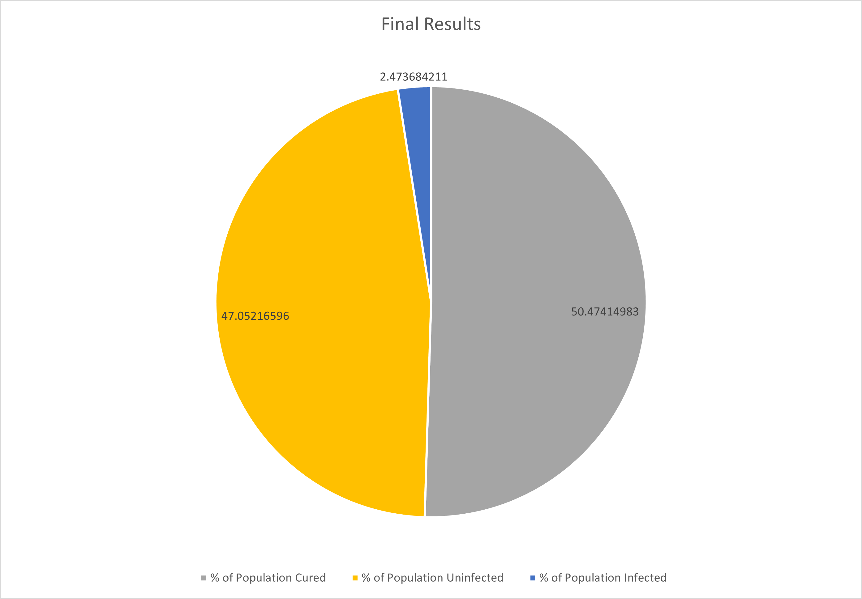

Figure 1.1.2 – Mask Control Model Final Results

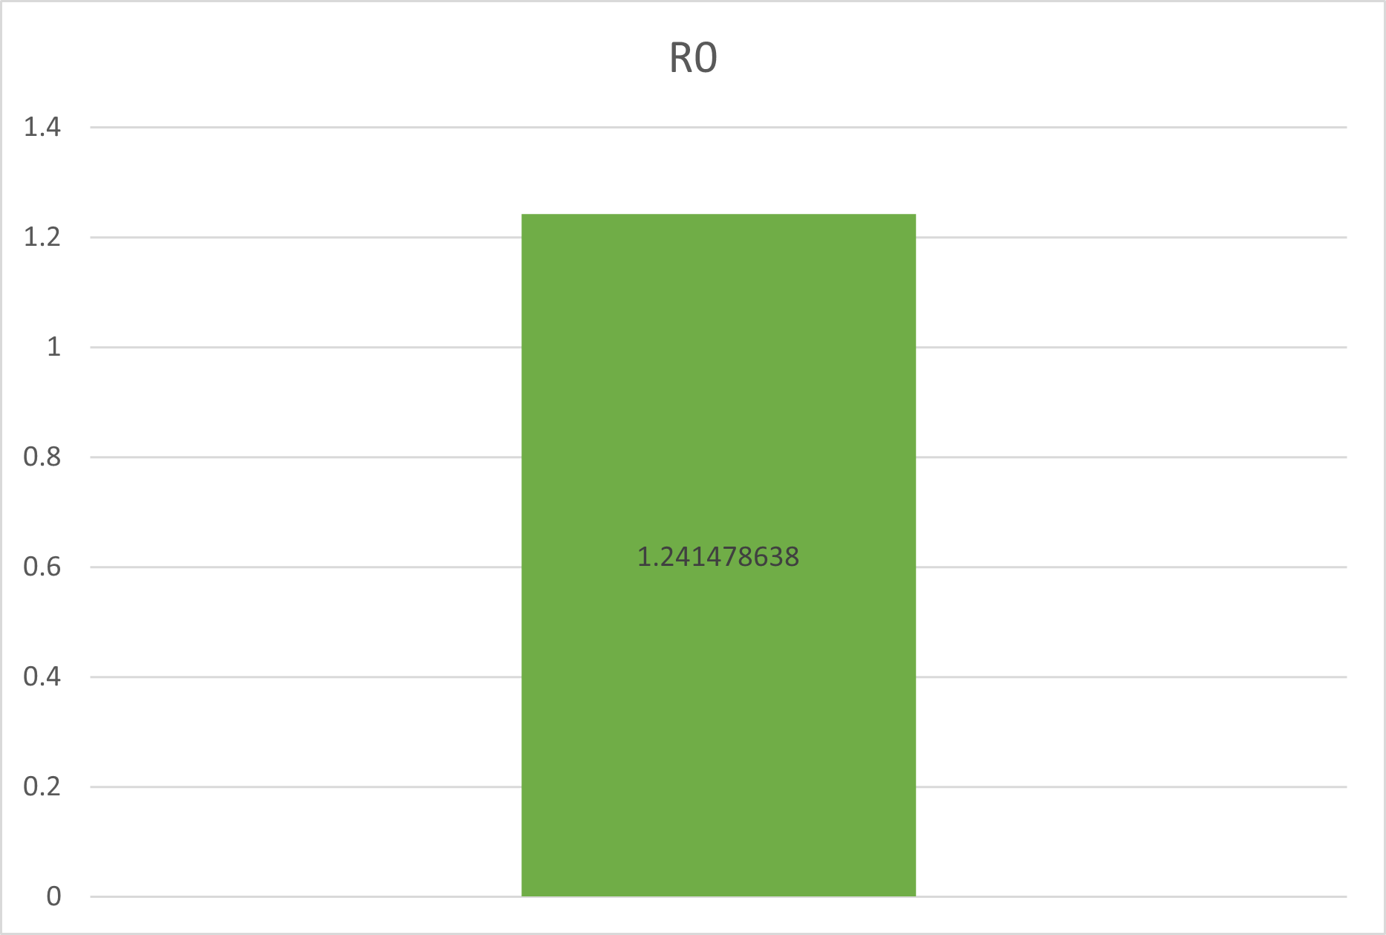

Figure 1.1.3 – Mask Control Model R0 Contractability

**Mask Model - 25% Masked**

**Variables**

In the first set of simulations ran after the control, the initial mask population was set to 25 out of 100.

**Results**

Simulations ran for an average of 22 days. The percentage of total infected peaked at day 6 at 2.78%. By the end of day 22, the percentage of total infected averaged at 2.88%. The total percent of non-infected dropped on day 9 to 92.72%. 21.73% of the population had been infected, and 75.49% of the population was had been uninfected on average over the 100 simulations. 2.875% of the population was left infected, however this was accounted for by the fact that some simulations ran past 22 days. The R0 was 0.688504522.

Figure 1.2.1 – 25% Masked Cumulative Behaviour

Figure 1.2.2 – 25% Masked Final Results

Figure 1.2.3 – 25% Masked R0 Contractability

**Mask Model - 50% Masked**

**Variables**

In the second experiment, the initial mask population was changed to 50 out of 100.

**Results**

Simulations for this experiment ran an average of 14 days. The percentage of total infected was highest at day 1 at an average of 4.82%. The percentage of total non-infected was lowest on day 1 as well at 95.18%. By the end of day 14, the total percentage of infected averaged at 2.06%, and the total non-infected population was 97.94%. On average of 100 simulations, 88.81% of the population were left uninfected, and 9.14% had been infected leaving 2.06% still infected. The R0 was 0.37250944%.

Figure 1.3.1 – 50% Masked Cumulative Behaviour

Figure 1.3.2 – 50% Masked Final Results

Figure 1.3.3 – 50% Masked R0 Contractability

**Mask Model - 75% Masked**

**Variables**

For the third experiment, the initial mask population was set to 75 out of 100 turtles.

**Results**

Simulations for this experiment ran for 10 days on average. The average peak for the total non-infected was on day 1 reaching 4.91%. The lowest the average total non-infected was on day 1 at 95.09%. On day 10, the total infected population was 1.42%, and the total non-infected population was 98.58%. Over the 100 simulations, 92.60% of populations were not infected on average, 5.98% of populations had been infected but recovered, and 1.42 were infected.

Figure 1.4.1 – 75% Masked Cumulative Behaviour

Figure 1.4.2 – 75% Masked Final Results

Figure 1.4.3 75% Masked R0 Contractability

**Mask Model - 100% Masked**

**Variables**

For experiment 4, the initial mask population was 100 out of 100 turtles, where all turtles were wearing masks and protected to a degree from transmission.

**Results**

Simulations for this experiment ran for 9 days on average. The peak for the average total infected was again on day 1, where the total was 5.07%, and the lowest total of non-infected was 95.09% on day 1 as well. The averages for day 9 were 1.27% for total infected and 98.73% for total non-infected. Over the 100 simulations, 93.16% of the populations were non-infected on average, 5.57% were infected but recovered, and 1.27% was left infected. The R0 was 0.124452034.Graphical user interface, text, application, email

Figure 1.5.1 – 100% Masked Cumulative Behaviour

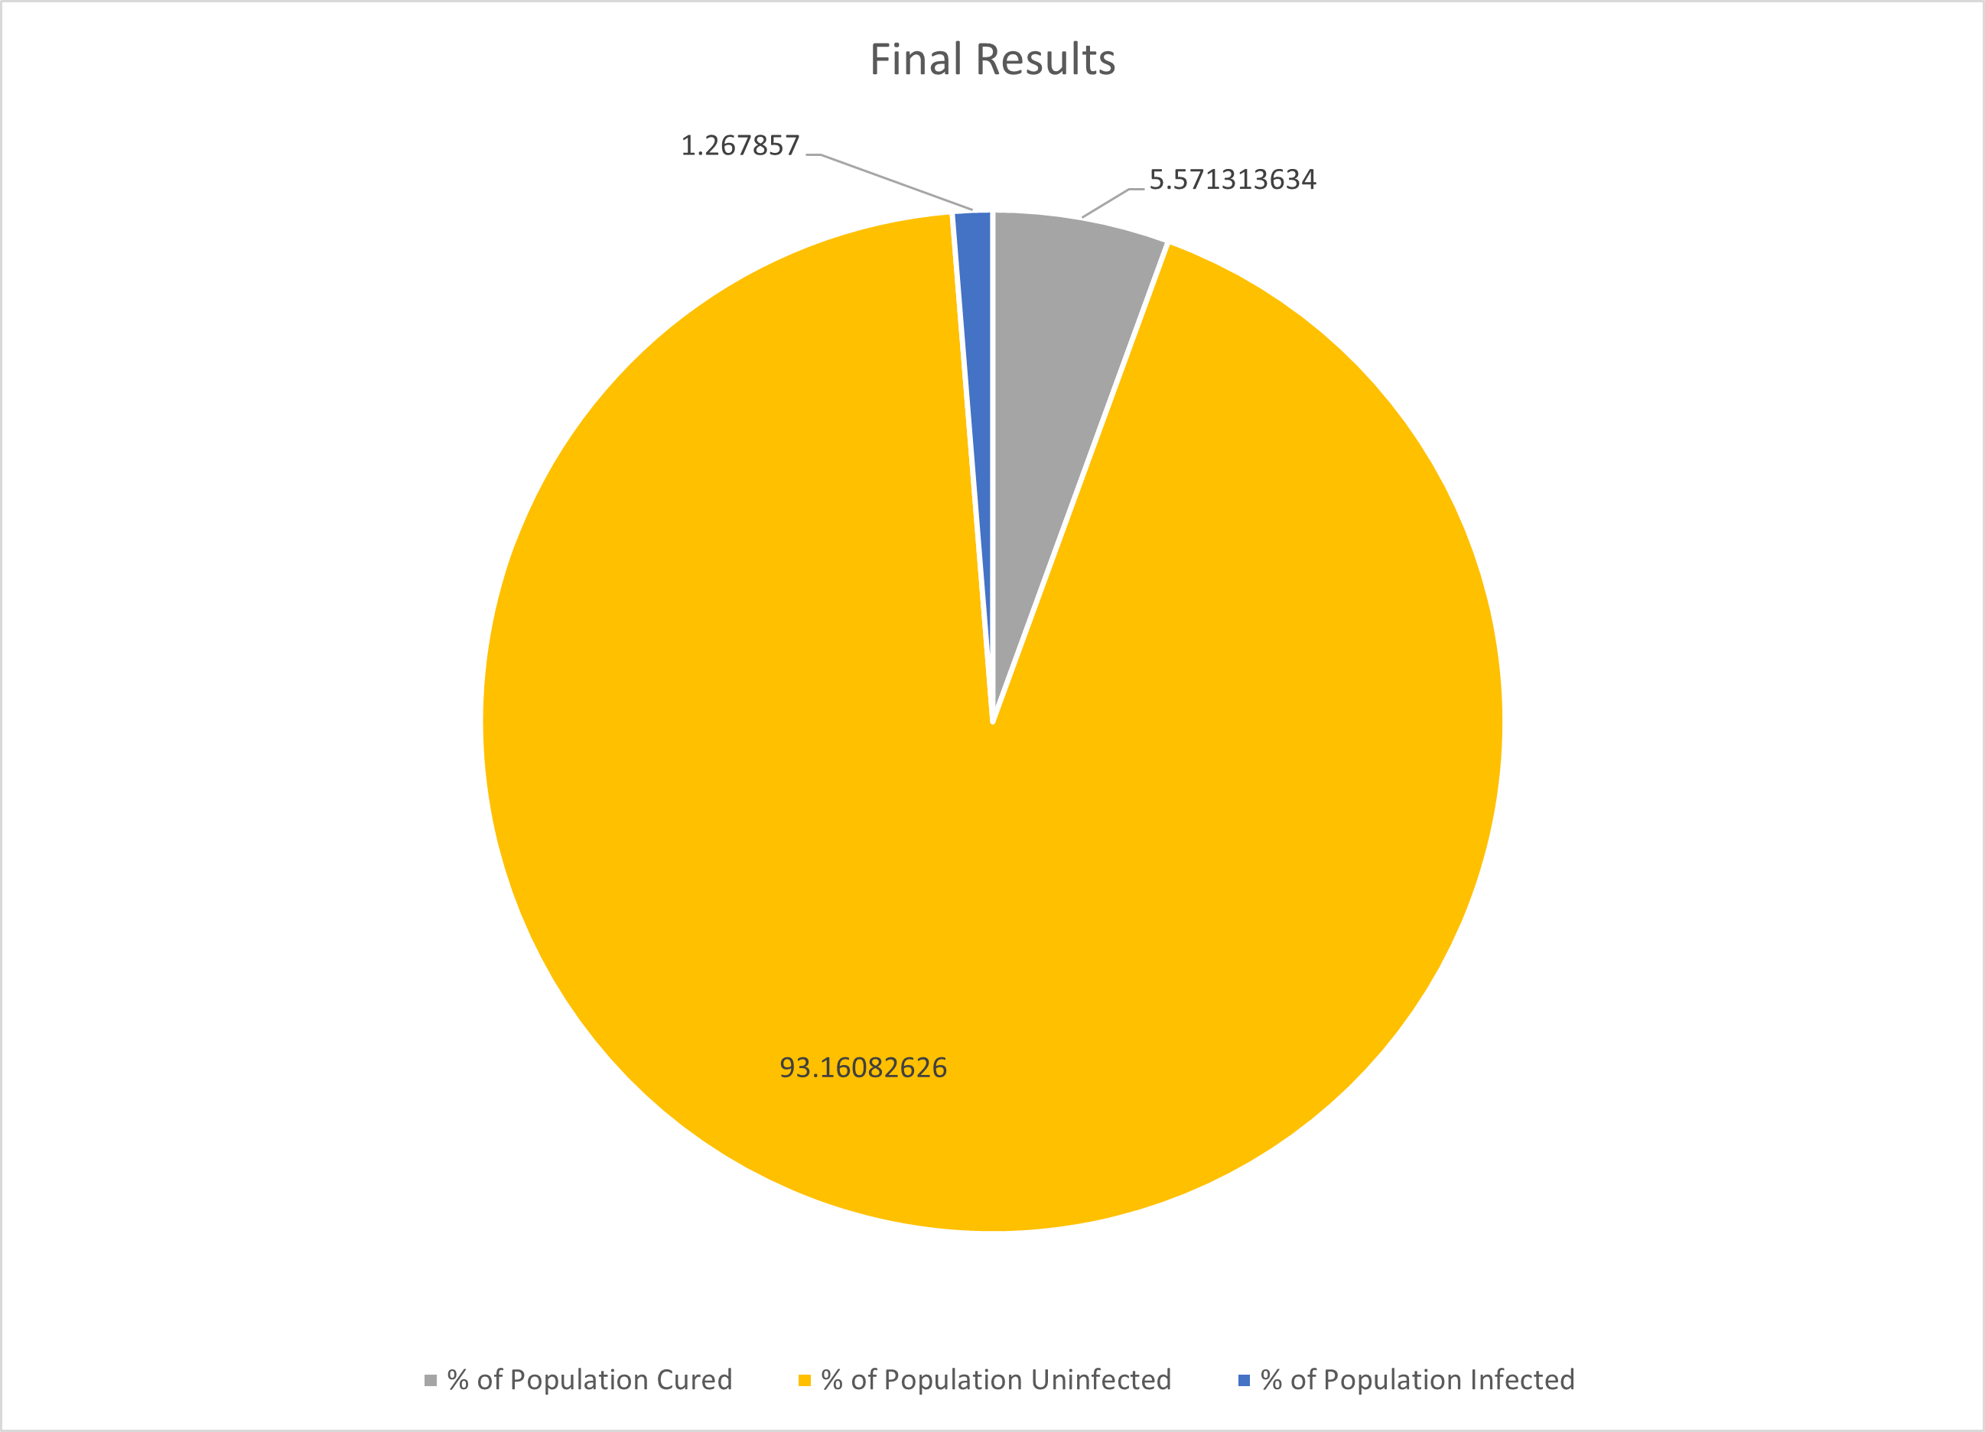

Figure 1.5.2 – 100% Masked Final Results

Figure 1.5.3 – 100% Masked R0 Contractability

**Findings**

The first finding worth noticing is the length of pandemics for each experiment. In the control model, the simulations ran for an average of 35 days, as the mask population increases however, it is very evident that the simulations ran were shorter than the control. In experiment 1, the simulations ran for an average of 22 days, in experiment 2 the simulations ran for an average of 14 days, in experiment 3 the simulations ran for an average of 10 days and experiment 4 was only 9 days. This shows a significant effect the masks have on preventing transmission and ensuring a shorter period of time in which the virus is spreading.

In the control experiment, the peak number of total infected turtles in the population was on day 7, indicating the infection spreading quickly causing the population to total to increase over time, however, apart from experiment 1, in the other experiments with the introduction of masks the peak was on day 1. This indicates that the masks were effective enough in preventing transmission that the infected population decreased quicker than it was able to spread and increase. In experiment 1, the peak was on day 9, but this also supports the hypothesis that masks can slow the spread of the virus across the network.

Another finding worth noting is the average number of people who were infected or non-infected over the 100 simulations. In the control model, the average percentage of the population infected per simulation was 50.47% and the average non-infected, that is never got infected, was 47.05%. In experiment 1, the average infected decreased significantly to 21.73% and the non-infected average increased to 75.39%. This indicates the with the implementation of more masks into the population, the less turtles that would be infected in the population.

The final result worth noting is the decrease in R0 as masks were implemented. We calculated the average R0 as 1.2233. In the control model, we had an average R0 of 1.241478638. However as the masks were implemented into the population, a decrease in R0 was observed. There was a significant decrease in R0 over experiment 1, 2 and 3, however for experiment 4 the decrease was smaller. The range found from research was 0.19-2.4. By experiment 3, the R0 for our simulations had decreased to 0.155952292 and for experiment 4 where the entire population was wearing masks the R0 was 0.124452034. Both of these R0 were outside of the researched range, indicating a significant effect on R0 with implementation of masks.

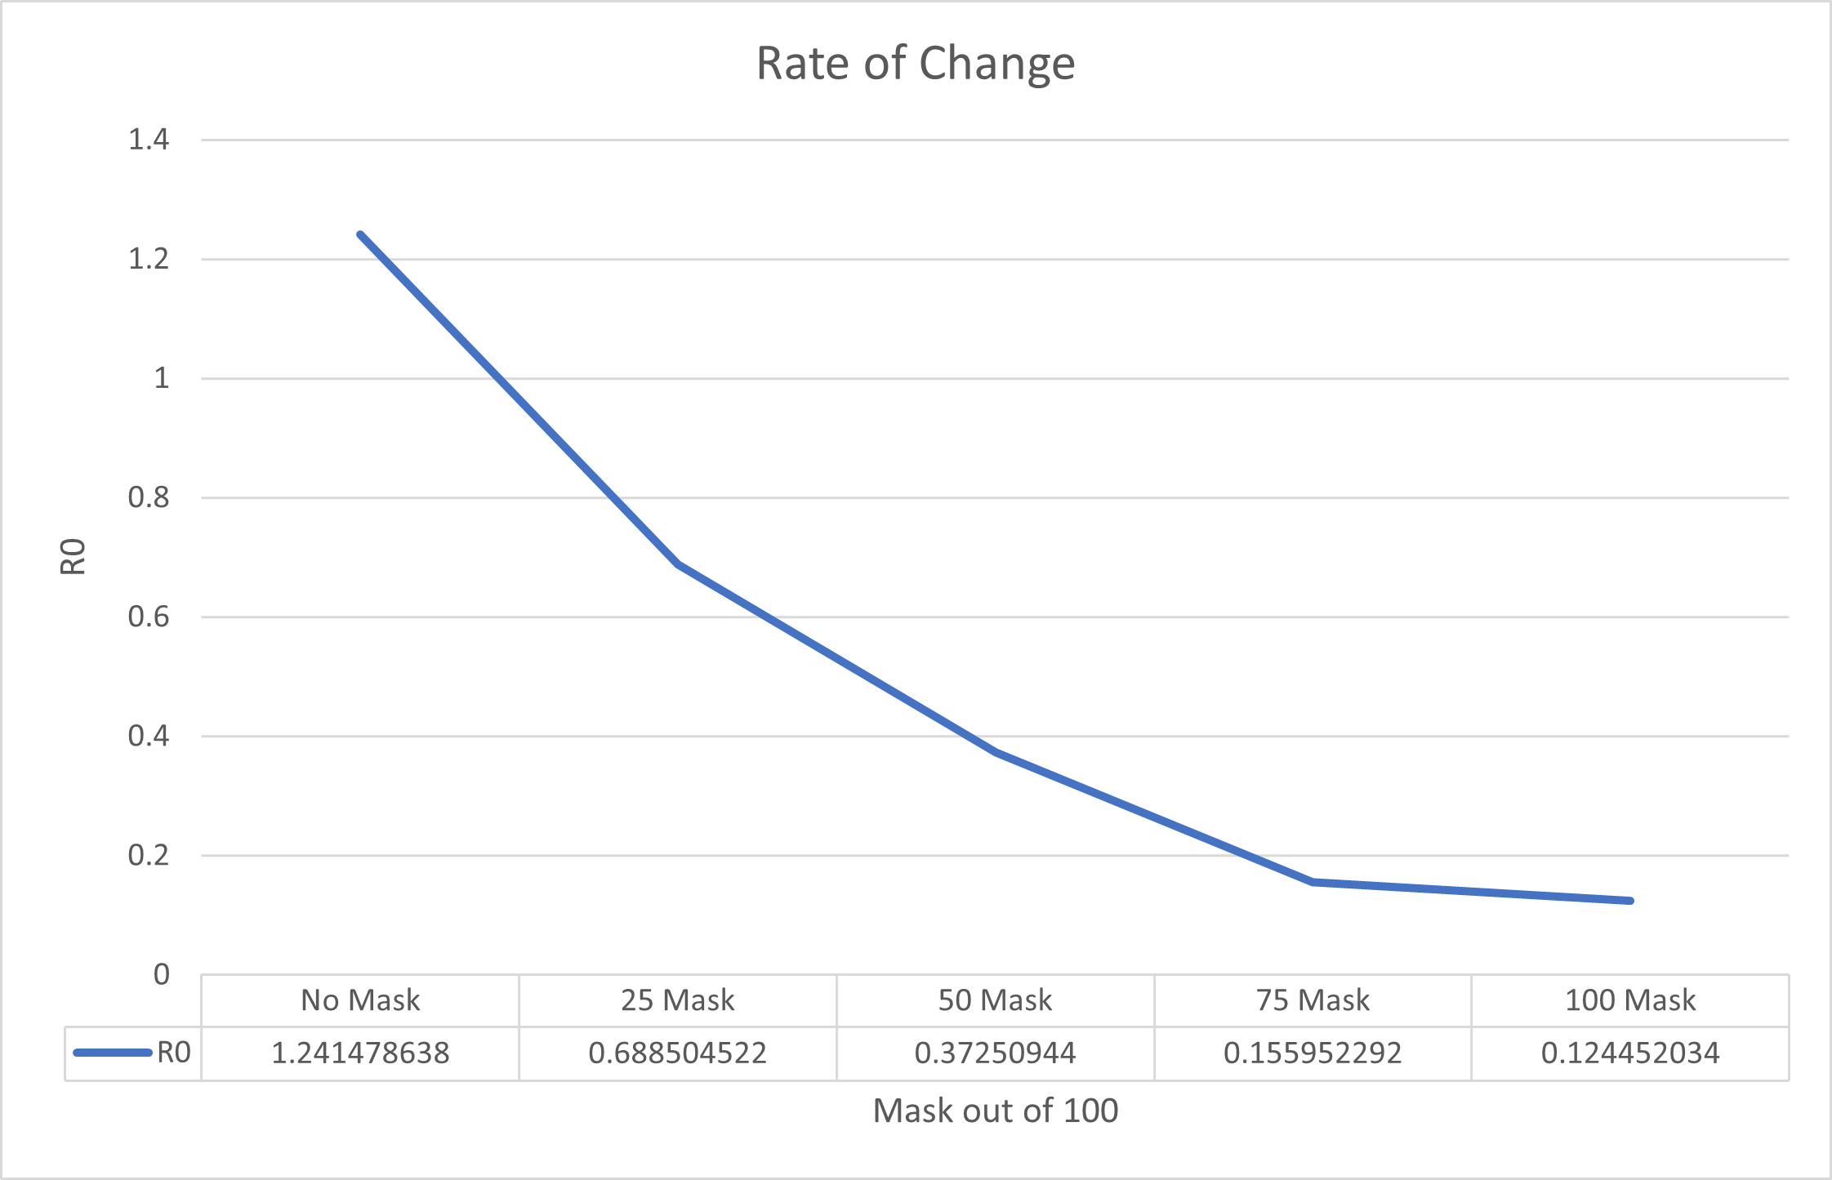

Figure 1.6 – Masks - *R0 Values of Control Model and All Vaccination Experiments*

**Conclusion**

From analysis of the results, it is evident that masks can have a significant effect in reducing the spread of a virus across a network. The infected population decreases with the implementation of masks to the population, and as more masks are introduced, the less the virus can spread as seen due to the R0.

# Vaccine Model

**Introduction**

This model was created to investigate the effectiveness of vaccinated turtles mixed into a population of unprotected turtles, enabling the assessment of the protection method used and the transmissibility rate of the virus.

For this model, the vaccine is assumed to be 100% effective at preventing both contracting the virus and vaccinated turtles from infecting non vaccinated turtles. The reason for this is purely experimental since there is no known working vaccine currently available for the strain of virus in this study. This study is only interested on the effect that such a vaccine may present.

**Code and Variables**

This model is based upon the previous model and was modified to include vaccinated turtle populations. The code was further modified to include more dynamic condition statements to handle how the infection will spread based on the interaction of each group of turtles and their retrospective attributes.

Variables used for this model are as follows; initial-people, recovery-chance, infection-chance, average-recovery-time, initial-people-mask, initial-people-vaccine and mask-effectiveness.

**Control model**

The purpose of the control model is to set a form of standard results to compare to when procuring results for other simulation runs later in the experimental phase. The control is required to keep all variables at a fixed value and remain fixed for all simulation runs for the control model. In order to examine the effects of a virus spread within an autonomous agent-based environment, the *Vaccine* variable in this control experiment remained at zero. This allows for comparative statistical analysis on later simulation runs, where the *Vaccine* variable will increase incrementally. This data will signify the potency of incorporating adoption of vaccines within a social environment distributing the virus.

**Variables**

For the *Vaccine* model, five variables were used within NetLogo to simulate the SARS-CoV-1 virus. The experiment was kept at a constant of 100 agents. The variables used are as follows:

*Initial-people-vaccine:* How many agents begin in the simulation with a vaccine, leaving them unable to catch the virus. This variable was altered during the experiment in order to compare the significance of vaccines within the environment. This is the primary variable that was altered to compare simulation runs against the control model.

*Initial-people:* This variable coincided with *Initial-people-vaccine*. As the population was required to remain at 100 agents, as the *Initial-people-vaccine* variable increased, it in turn scaled down the number of regular agents that were susceptible to the virus. The *Initial-people* are susceptible to beginning the simulation uninfected or infected, unlike the vaccinated agents which were a part of the population, and are unsusceptible to the virus.

*Infection-chance:* This value remained stagnant. This value remained at 50% giving each agent susceptible to the virus an even chance of catching it when coming in close contact with an infected agent.

*Recovery-chance:* This value remained stagnant. This value remained at 87.5%, displaying an agent’s chance of recovery when becoming infected with the virus. This variable also assumes a 12.5% mortality rate for SARS-CoV-1. (Paules, 2020) (World Health Organisation, 2003)

*Average-recovery-time:* This value remained stagnant. Average amount of days (on ticks) it takes for an agent to recover from the virus. This value was set to 18 days/ticks. (CDC.gov, 2021)

**Results**

For the control model, and all other experiments, 100 simulation runs were performed and compiled into data. For the *Vaccine* model, six experiments were carried out, totalling to data collected from 600 simulation runs.

Graphs below are representative for the control model. 100 iterations of the simulation were run. The average duration of each run lasted 35 days within the simulated environment, with the peak of infections occurring approximately between days 7 and 12.

The control model displays without any interference with vaccines being incorporated, half of the population (52.3%) will have been infected by the by the virus by day 35.

(Figure 2.1.1) With the total amount of infected individuals being 3.6% by the end of the 35 days, alongside the 50% contractability chance set up as mentioned in the variables section of this model, it can be assumed the virus would have not lasted much longer than the 35-day average. This in turn can assume the SARS-CoV-1 virus is short lived during a pandemic-like situation.

*Figure 2.1.1 – Control Model Virus Spread*

(Figure 2.1.2) The graph displays the number of infected peaking in the early days of the virus and a steady downtrend as it almost plateaus near zero infections by day 35.

*Figure 2.1.2 – Control Model Cumulative Behaviours*

(Figure 2.1.3) the R0 is calculated and displayed. R0 represent the contractability, how infectious or likely a disease will be spread. If this number is over one, the virus is susceptible to breaking out to an epidemic.

*Figure 2.1.3 – Control Model R0 Contractability*

If the R0 is equal to one, it will remain stable and controllable within its environment, but still capable of spreading and increasing the R0 value. A value under one deems the virus to not be as infectious or can be predicted to be heading in a downtrend and infecting less people over time, until the R0 value reaches zero. The R0 values attempts to signify within the value on average, how many people are likely to be infected per infected individual in the environment. In this scenario, the average person will infect 1.2 people if they carry the virus. (Ramirez, 2020)

To conclude, we can assume this control model simulation is likely to breakout into an epidemic given its R0 value.

**Vaccine Model – 25% Vaccinated**

**Variables**

Variables are same as the control model, *Initial-people-vaccine* is set to 25, and *Initial-people* is set to 75. This is to compensate for the increased number of agents that are vaccinated, as the total population must remain at 100 for all experiments.

**Results**

The virus lasted on average 24 days over the 100 runs of the first vaccine model experiment. A decrease of 11 days compared to the control model, significantly identifying a vaccine’s strength in infection mitigation even in the lower percentages.

(Figure 2.2.1) With the integration of 25% being vaccinated, a drastic change of 28% less agents becoming infected with the virus, in comparison with the control model’s statistics.

*Figure 2.2.1 – 25% Vaccinated Final Results*

(Figure 2.2.2) Total number virus cases begin plateau at approximately day 21 as new cases of the virus spread fail to emerge, as the infected numbers consistently decrease from day 5, unable to break 6% of total infected at one time.

*Figure 2.2.2 – 25% Vaccinated Cumulative Behaviours*

*Figure 2.2.3 – 25% Vaccinated R0 Contractability*

With a quarter of the agent population vaccinated, and the R0 value significantly lower than the control model’s value, this model decreased in both infection cases and simulation length. Decreasing the R0 value under one signifies positive strength in minor vaccine integration and likely to continue in further experiments with higher vaccinated agent values.

**Vaccine Model – 50% Vaccinated**

**Variables**

Variables are same as the control model, *Initial-people-vaccine* is set to 50, and *Initial-people* is set to 50. This is to compensate for the increased number of agents that are vaccinated, as the total population must remain at 100 for all experiments.

**Results**

The virus lasted on average 14 days over the 100 runs of the second vaccine model experiment. A decrease of 21 days compared to the control model, and a 10-day decrease from the previous ‘25% Vaccinated’ model.

(Figure 2.3.1) With the integration of 50% of the agent population being vaccinated, 89.5% of agents had not contracted the virus at all. The remainder led to 8% recovering from the from virus and 2% having contracted the virus by the fourteenth day. This leads to another 42% of the whole population to not contract the virus on top of the control model’s statistics.

*Figure 2.3.1 – 50% Vaccinated Final Results*

(Figure 2.3.2) The total number of infected at any time fails to break 3% of the total population, thus assuming the vaccine’s strength as it doubles within the population, halving both the average duration of the simulation and infected per day.

*Figure 2.3.2 – 50% Vaccinated Cumulative Behaviour*

*Figure 2.3.3 – 50% Vaccinated R0 Contractability*

With half of the agent population vaccinated, the R0 value is less than half of the control model’s value. Also, with a 0.26 decrease in the R0 compared to the ‘25% Vaccinated’ model, the virus’ efficacy in spreading is gradually lagging. Decreasing the R0 value under one signifies positive strength in further integration of vaccines within the population. With comparison, 52% of the population infected within the control, and 10% in the current model with half the population vaccinated, it can be easily assumed with an implied 12.5% mortality rate that deaths will have significantly decreased or reached negligible numbers with the increased implementation of vaccinations.

**Vaccine Model – 75% Vaccinated**

**Variables**

Variables are same as the control model, *Initial-people-vaccine* is set to 75, and *Initial-people* is set to 25. This is to compensate for the increased number of agents that are vaccinated, as the total population must remain at 100 for all experiments.

**Results**

The virus lasted on average 4 days over the 100 runs of the third vaccine model experiment. A decrease of 31 days compared to the control model, and a 10-day decrease from the previous ‘50% Vaccinated’ model. A reoccurring trend appears to take place as the model increases 25% in vaccinated agents, the duration of the simulation decreases by 10 days.

(Figure 2.4.1) The integration of 75% of the population being vaccinated leads to negligible amounts of cases, coinciding with a short simulation duration, as previously mentioned, an average duration of 4 days. A 7% increase in uninfected agents leads to less than 3% of the population becoming infected and does not surpass more than one agent being infected at any one time.

*Figure 2.4.1 – 75% Vaccinated Final Results*

(Figure 2.4.2) With three-quarters of the population vaccinated and unsusceptible from contracting and spreading the virus, the simulated SARS-CoV-1 virus fails to spread among the agents and is rejected quickly by the environment.

*Figure 2.4.2 – 75% Vaccinated Cumulative Behaviour*

Figure 2.4.3 – 75% Vaccinated R0 Contractability

With an R0 of 0.144 as displayed above, with the sole observation of the R0 value it can be asserted that the simulated virus heavily struggles to infect new agents in order to spread the virus further.

**Vaccine Model – 85% Vaccinated**

**Variables**

Variables are same as the control model, *Initial-people-vaccine* is set to 85, and *Initial-people* is set to 15. This is to compensate for the increased number of agents that are vaccinated, as the total population must remain at 100 for all experiments. With the observation that the R0 value is nearing zero, and statistics begin to approach a plateau, it is important to increase the vaccinated agents gradually, to observe the approach towards a fully vaccinated environment and, what is the earliest point that the population is safe from the virus’ harmful spread.

**Results**

The virus lasted on average 3 days over the 100 runs of the fourth vaccine model experiment. A decrease of 32 days compared to the control model, and a 1-day decrease from the previous ‘75% Vaccinated’ model. Here it is increasingly visible that infection numbers begin to plateau.

(Figure 2.5.1 & 2.5.2) Not much change from the previous experiment, as this simulation struggles to surpass infecting 1% of the population. Leading to a 1% increase in uninfected agents, it displays that another 10% increment in vaccinations at this stage is minute in its effect, but positive in controlling the virus.

*Figure 2.5.1 – 85% Vaccinated Final Results*

*Figure 2.5.2 – 85% Vaccinated Cumulative Behaviour*

*Figure 2.5.3 – 85% Vaccinated R0 Contractability*

**Vaccine Model – 90% Vaccinated**

**Variables**

Variables are same as the control model, *Initial-people-vaccine* is set to 90, and *Initial-people* is set to 10. This is to compensate for the increased number of agents that are vaccinated, as the total population must remain at 100 for all experiments. With the observation that the R0 value is nearing zero, and the statistics approach a plateau, it is important to increase the vaccinated agents gradually.

**Results**

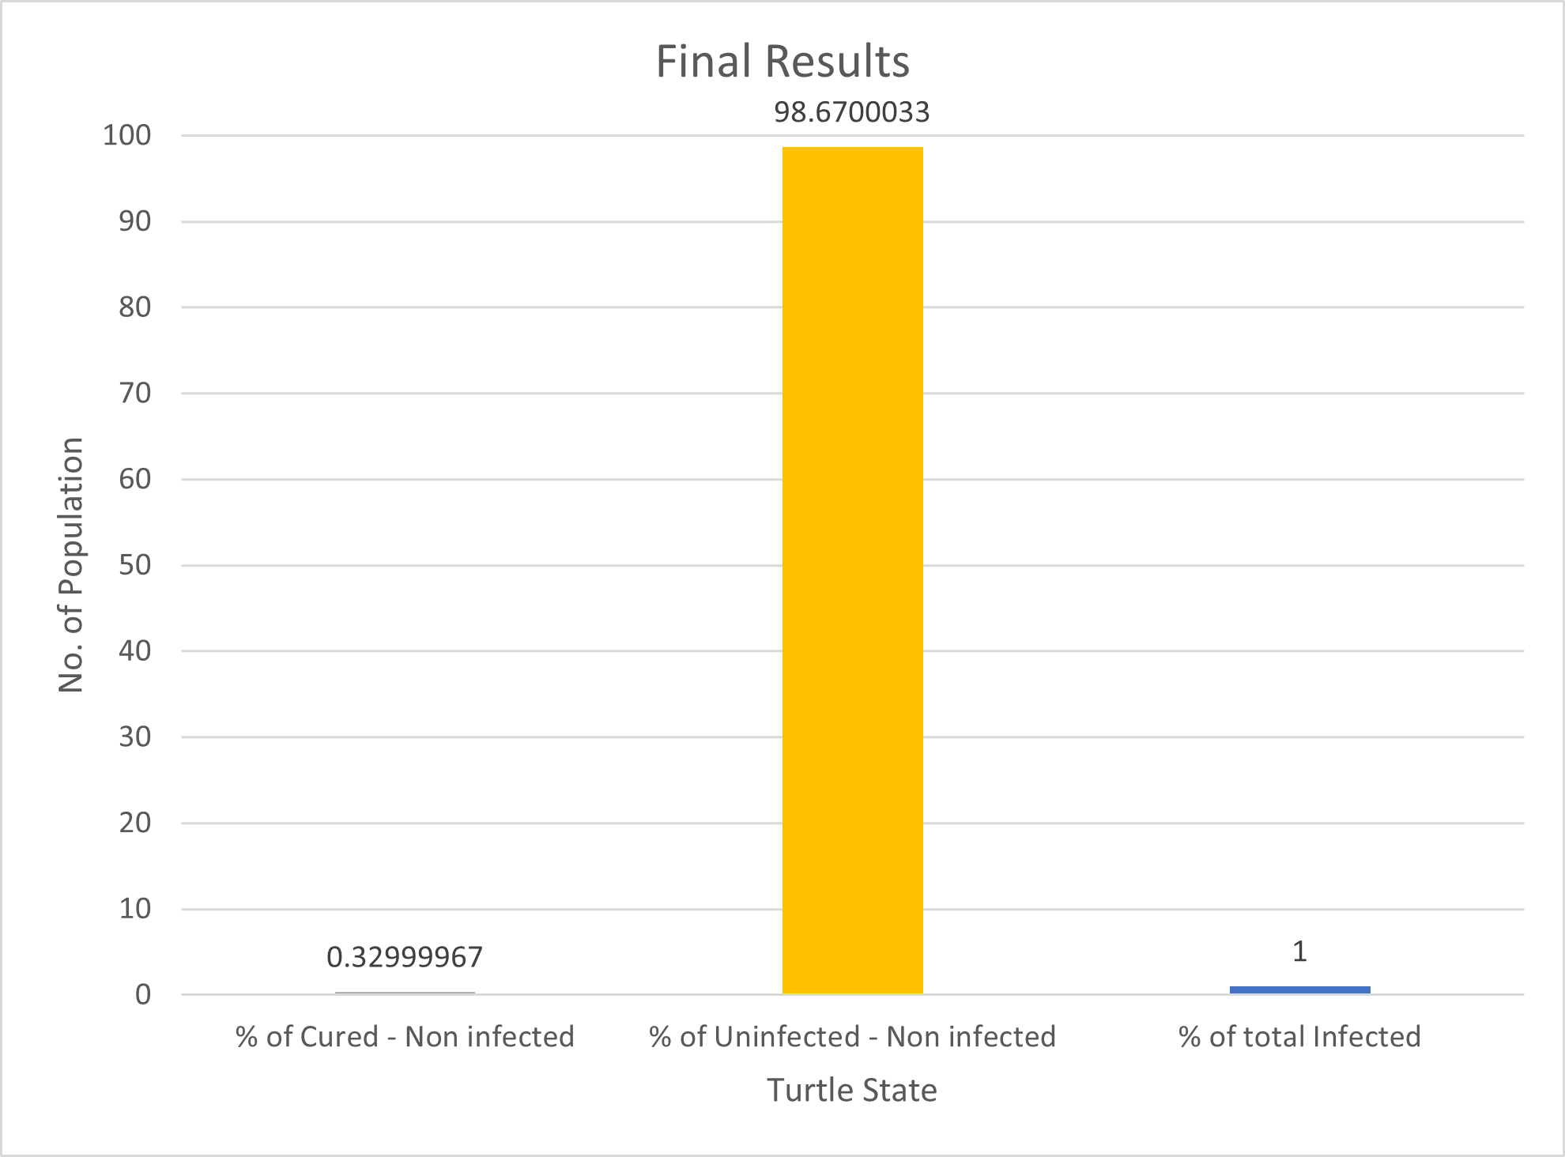The virus lasted on average 3 days over the 100 runs of the fifth and final vaccine model experiment. A decrease of 32 days compared to the control model, and no decrease in the days regarding the virus’ duration of activity within the environment compared to the previous ‘85% Vaccinated’ model. Infection numbers plateau and continuously decrease but in a negligible manner, as the increase in vaccinations appears to barely decrease the infections and simulation duration. This is positive data as the plateau signifies strength in analysing the data for the starting point of the consolidation to identify a number of vaccinations to be met in order to see strength in mitigating the R0 and new infections.

*Figure 2.6.1 – 90% Vaccinated Final Results*

(Figure 2.6.1 – 2.6.3) The initial infected in a majority of the simulation runs failed to infect another person, displaying a R0 value of 0.03, assigning the virus as virtually having no effect at 90% vaccinated agent environment.

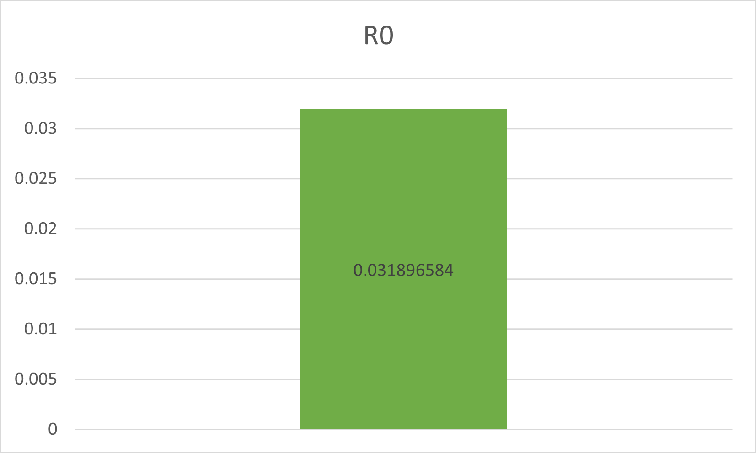

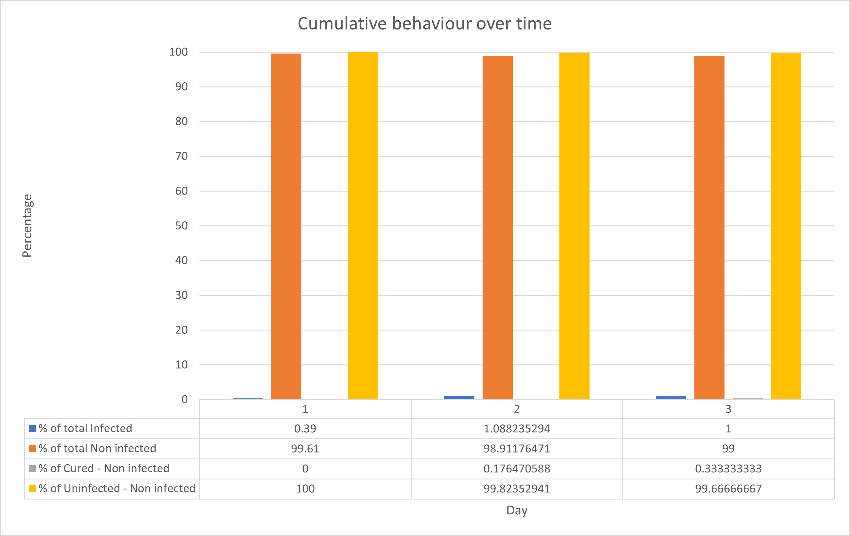

*Figure 2.6.3 – 90% Vaccinated R0 Contractability*

*Figure 2.6.2 – 90% Vaccinated Cumulative Behaviour*

**Findings**

**Analysis**

As mentioned in the development of each experiment, between the control model and the first three vaccine model experiments, the 25%, 50% and 75% display positive strength in the incorporation of virus spread mitigation, progressively halving the total number of infections whilst incrementing the number of vaccinated agents.

When analysing the plateau of the infections and R0 value in the later experiments, specifically the 85% and 90% models, it displays a slight alter in direction when the 75% model is performed. With a 0.144 R0 value, it signifies that further vaccinations will further strengthen the population as a whole from the likelihood of new infections spreading. With the R0 value this low, SARS-CoV-1 is no longer concerning for the agents, as the virus is extremely likely to diminish within the next few days.

This does not assert that the 25% and 50% models are not useful in mitigating virus spread. If progressively implementing vaccinations to a population overtime, decrease in the R0 can be expected to act similarly to the R0 graph below (Figure 7.1). The 25% model is the largest benefactor towards decreasing the R0 value, as it drops the control model from 1.19 down to 0.76, with a difference of 0.43. This initial insert of vaccinating 25% of the population greatly decreases the SARS-CoV-1 likelihood of developing into an epidemic in a real-life scenario. This data allows the assumption that full vaccination of all members of an environment are not required to be vaccinated in order to begin preventing an epidemic-like scenario from occurring, or to mitigate infections in general.

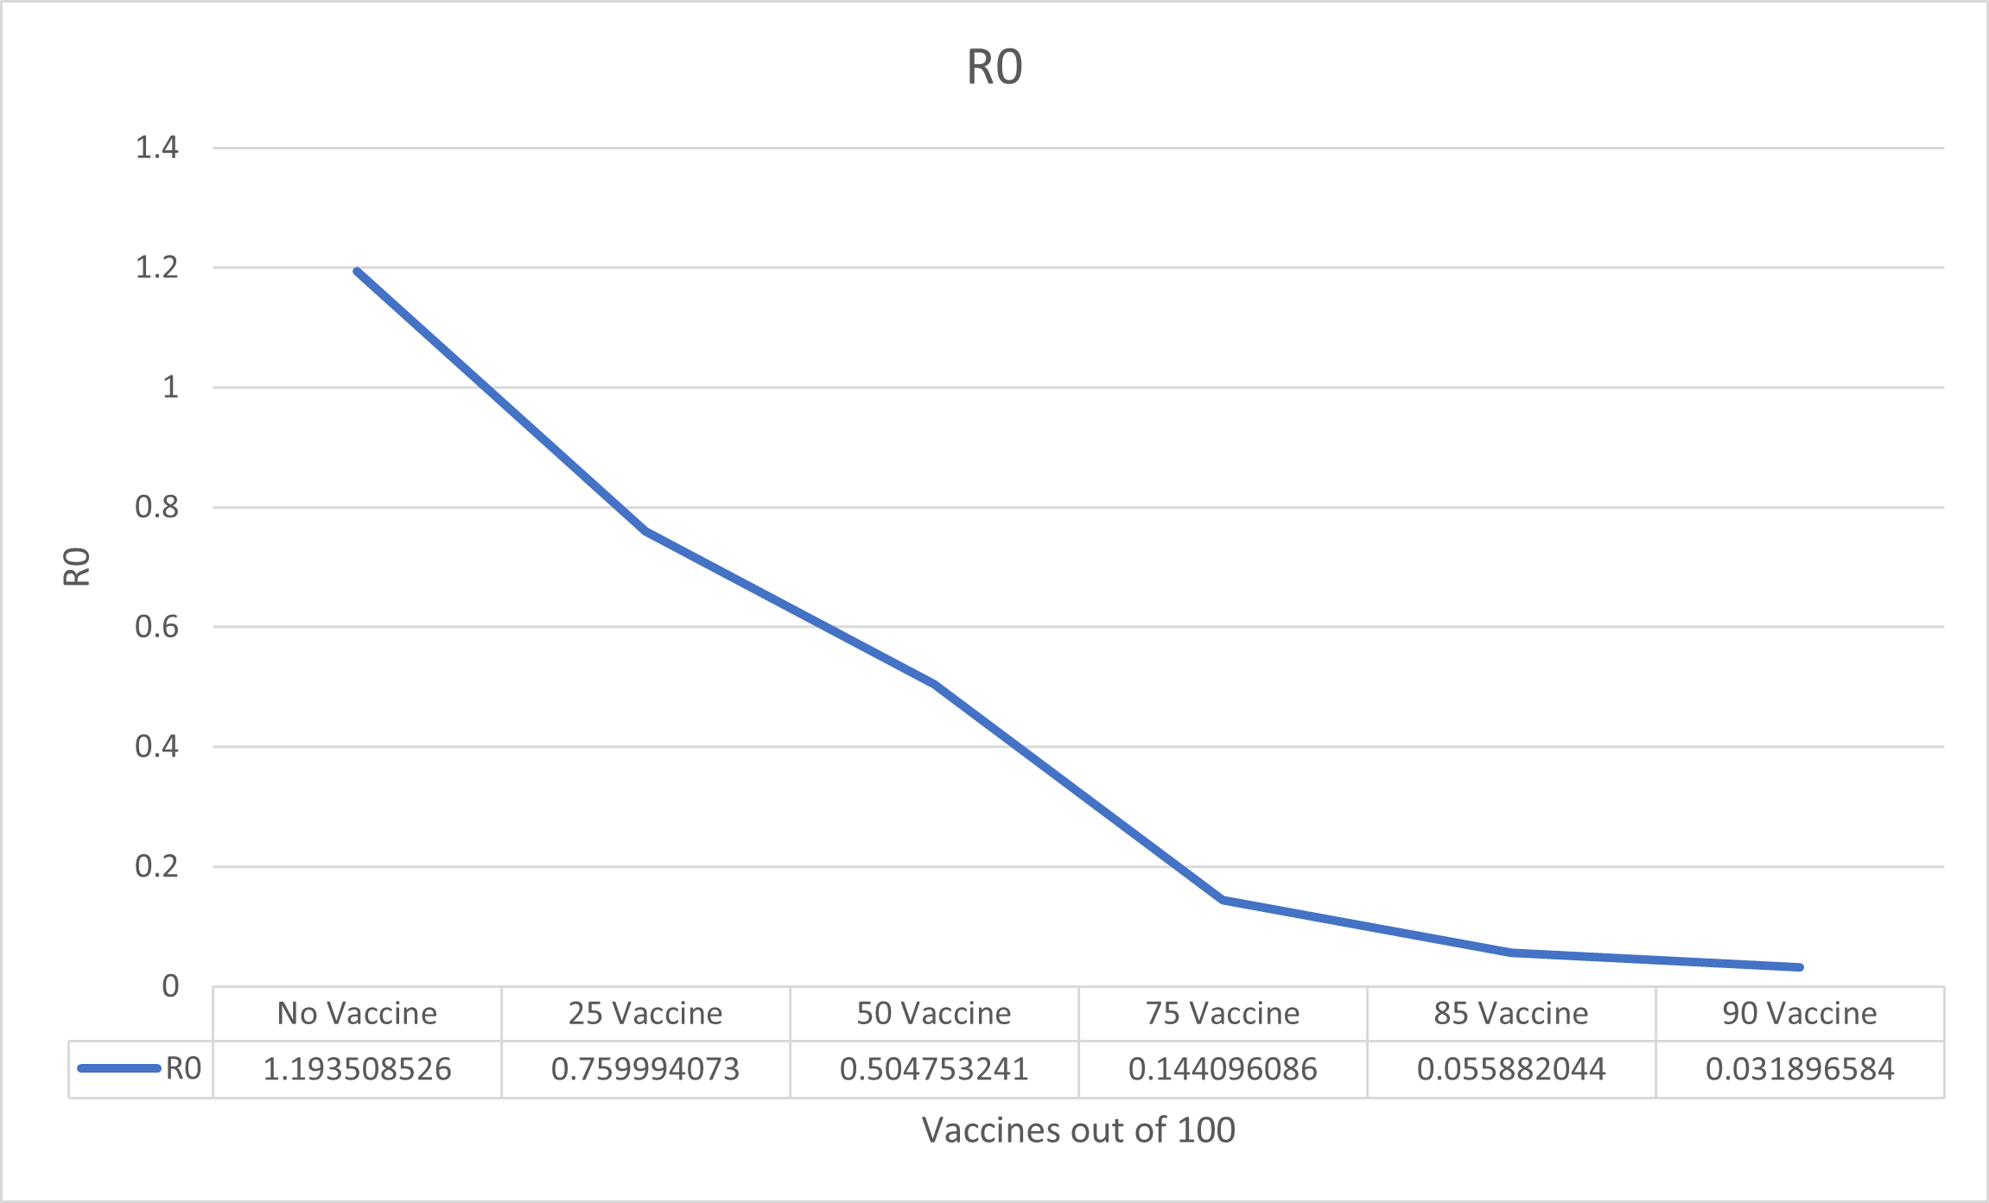

*Figure 2.7 – Vaccine - R0 Values of Control Model and All Vaccination Experiments*

**Conclusion**

The aim of this experiment is to analyse and discuss trends within a simulated environment with the spread of the SARS-CoV-1 virus, alongside the observation of vaccinations. The initial control model had an R0 above one, which represents high susceptibility of an epidemic. Through five experiments scaling in vaccination implementation, from 25%, 50%, 75%, 85% and 90%, it allowed for analysis to identify strength and significance in each phase of vaccine adoption. This assisted in identifying the significance of the 25% and 75% models. The 25% model decreased the R0 by the largest amount (0.43), drastically decreasing the infections from the control model (52%) to the 25% vaccinated model (25%). The 75% model transitions greatly from the 50% model and it captures the beginning of a plateau in cases with an extremely low R0 (0.14) that prevents the virus from exceeding five days, or more than one agent being infected at any given time.

# Vaccine & Mask Model

**Introduction**

This model was created to investigate the effectiveness of both masked and vaccinated turtles mixed into a population of unprotected turtles, enabling the assessment of both protection methods used and the transmissibility rate of the virus.

This data can then be further extrapolated and compared to the previous 2 models in assessing if masks and vaccines are utilised in combination show any noticeable difference in the infection rate.

For this model, the vaccine is assumed to be 100% effective at preventing both contracting the virus and vaccinated turtles from infecting non vaccinated turtles. The reason for this is purely experimental since there is no known working vaccine currently available for the strain of virus in this study. This study is only interested on the effect that such a vaccine may present.

**Code and Variables**

This model is based upon the previous 2 models and was modified to include both masked and vaccinated turtle populations. The code was further modified to include more dynamic condition statements to handle how the infection will spread based on the interaction of each group of turtles and their retrospective attributes.

Variables used for this model are as follows; initial-people, recovery-chance, infection-chance, average-recovery-time, initial-people-mask, initial-people-vaccine and mask-effectiveness.



**Control model**

In this study, for the purposes of calibrating and comparison, this model was run without any masked or vaccinated turtles enabled.

The results below are an average over time over 100 simulations over the average amount of days it took for the infection to subside.

**Variables**

Below are the details of the variables used and their set parameters for this experiment.

* ***initial-people*** was set at 100, this is the baseline population.
* ***recovery-chance*** was set at 87.5%, this is an extrapolated average based on the average death rate of the virus. SARS has a death rate between 10% (Paules, Marston and Fauci, 2020) and 15% (Update 49 - SARS case fatality ratio, incubation period, 2003).

Based on this; Death rate average is 15% + 10% = 25% / 2 = 12.5%.

Based on this, the survival rate is between 85%-90% with an average of 87.5%.

Recovery rate average is 85% + 90% = 175 / 2 = 87.5%.

* ***infection-chance*** was set at 50% to emulate a fair statistical chance of contracting the virus from contact with an infected induvial.
* ***average-recovery-time***was set to 18 days, this was an average based on the minimum, maximum and incubation periods of the SARS virus.

SARS has a typical incubation period of 2-7 days, possibly 10 days and rarely 14 days in which the infection cannot be transmitted (SARS | Frequently Asked Questions | CDC, 2021).

SARS, once symptoms show, infection can be transmitted, and 10 days should be allowed to pass from onset of symptoms to be considered non-infectious (SARS | Frequently Asked Questions | CDC, 2021).

Based on these numbers, SARS has a minimum duration of 12 days, average duration of 18 days and maximum duration of 24 days.

* ***initial-people-mask*** was set to 0, as this control experiment doesn’t include masked turtles.
* ***initial-people-vaccine*** was set to 0, as this control experiment doesn’t include vaccinated turtles.
* ***mask-effectiveness*** was set to 0%, as no masked turtles were present in this experiment.

All the variables used within this control model, except for initial-people, initial-people-mask, initial-people-vaccine and mask-effectiveness, will remain static. This will be further explained in each subsequent experiment.

**Results**

The below line graph shows the behaviour over time over the average number of days it took for the infection to subside.

The blue line represents the % of total infected turtles.

The orange line represents the % of total non-infected turtles.

The grey line represents the % of cured turtles within non-infected turtles, who contracted the virus and recovered.

The yellow line represents the % of uninfected turtles within non-infected turtles, who didn’t contract the virus.

The below results gathered from this experiment detail the transmissibility rate of the virus in an unprotected population and the length of time for which it takes to subside.

Figure 3.1.1 – Control Model Cumulative Behaviour

The above graph (Figure 3.3.1) shows the distribution of the infection throughout the population. The virus was present for a total of 35 days within the population and peak infection occurring between day 7 to 8, decreasing gradually thereafter.

The pie chart (Figure 3.1.2) illustrates the final day that the virus was present in the population. It clearly shows that on the final day the virus was present, approximately 47% of the entire population has previously been infected with approximately 3% currently infected. Based on this, the virus has successfully infected approximately 50% of the population.

Figure 3.1.2 – Control Model Final Results

The bar chart displayed shows the average final R0 rate over the 100 simulations of this experiment. The R0 rate indicated as approximately 1.22 is of importance as it is within the average R0 rate of real-world SARS data.

Figure 3.1.3 – Control Model R0 Contractability

According to (Dr. Osman Shabir, 2021) and (Petersen et al., 2020) SARS has an R0 rate of 0.19-1.08 and 2.4 retrospectively.

Based on the above sources, SARS virus has an average R0 of 1.2233 and range of 0.19-2.4.

R0 average is 0.19 + 1.08 + 2.4 = 3.67 / 2 = 1.2233 repeating.

This indicates, based on the variables parameters and the final R0 rate, that the control model is accurately calibrated and representing a real-world SARS outbreak within a 100-person population.

**Mask & Vaccine Model – 10% Masked & 10% Vaccinated**

The experiment introduces both masked and vaccinated turtles into the environment. The ratio utilized in the experiment is 10 masked turtles, 10 vaccinated turtles and 80 non-protected turtles.

This experiment is design to see if including both masked and vaccinated turtles into the environment will have any effect on the transmissibility of the virus.

The results below are an average over time over 100 simulations over the average amount of days it took for the infection to subside.

**Variables**

As explained in the control models variables section, all variables except 4 are static.

Below are the details of the variables that are modified for the purpose of this experiment.

* ***initial-people*** was set at 80, this is the baseline population.
* ***initial-people-mask*** was set to 10, as this control experiment doesn’t include masked turtles.
* ***initial-people-vaccine*** was set to 10, as this control experiment doesn’t include vaccinated turtles.
* ***mask-effectiveness*** was set to 80%, this reflects data on a study that shows adequate mask protection is at least 80% effective in preventing the spread and contraction of influenza like viruses (What is the evidence on wearing masks to stop COVID-19?, 2021).

For all subsequent experiments, the mask-effectiveness variable will now become static.

**Results**

The below line graph shows the behaviour over time over the average number of days it took for the infection to subside.

The blue line represents the % of total infected turtles.

The orange line represents the % of total non-infected turtles.

The grey line represents the % of cured turtles within non-infected turtles, who contracted the virus and recovered.

The yellow line represents the % of uninfected turtles within non-infected turtles, who didn’t contract the virus.

The below results gathered from this experiment detail the transmissibility rate of the virus in an unprotected population and the length of time for which it takes to subside.

Figure 3.2.1 – 10% Masked & 10% Vaccinated Model Cumulative Behaviour

The above graph (Figure 3.2.1) shows the distribution of the infection throughout the population. The virus was present for a total of 25 days within the population and peak infection occurring between day 4 to 7, decreasing gradually thereafter.

The pie chart (Figure 3.2.2) illustrates the final day that the virus was present in the population. It clearly shows that on the final day the virus was present, approximately 26% of the entire population has previously been infected with approximately 3% currently infected. Based on this, the virus has successfully infected approximately 29% of the population.

Figure 3.2.2 – 10% Masked & 10% Vaccinated Model Final Results

The bar chart (Figure 3.2.3) displayed shows the average final R0 rate over the 100 simulations of this experiment. The R0 rate indicated as approximately 0.80.

Figure 3.2.3 – 10% Masked & 10% Vaccinated Model R0 Contractability

**Mask & Vaccine Model – 20% Masked & 20% Vaccinated**

The experiment introduces both masked and vaccinated turtles into the environment. The ratio utilized in the experiment is 20 masked turtles, 20 vaccinated turtles and 60 non-protected turtles.

This experiment is design to see if including both masked and vaccinated turtles into the environment will have any effect on the transmissibility of the virus.

The results below are an average over time over 100 simulations over the average amount of days it took for the infection to subside.

**Variables**

As explained in the previous experiment’s variables section, all variables except 3 are static.

Below are the details of the variables that are modified for the purpose of this experiment.

* ***initial-people*** was set at 60, this is the baseline population.
* ***initial-people-mask*** was set to 20, as this control experiment doesn’t include masked turtles.
* ***initial-people-vaccine*** was set to 20, as this control experiment doesn’t include vaccinated turtles.

**Results**

The below line graph shows the behaviour over time over the average number of days it took for the infection to subside.

The blue line represents the % of total infected turtles.

The orange line represents the % of total non-infected turtles.

The grey line represents the % of cured turtles within non-infected turtles, who contracted the virus and recovered.

The yellow line represents the % of uninfected turtles within non-infected turtles, who didn’t contract the virus.

The below results gathered from this experiment detail the transmissibility rate of the virus in an unprotected population and the length of time for which it takes to subside.

Figure 3.3.1 – 20% Masked & 20% Vaccinated Model Cumulative Behaviour

The above graph shows the distribution of the infection throughout the population. The virus was present for a total of 16 days within the population and peak infection occurring between day 1 to 4, marginally decreasing throughout the remaining days.

The pie chart illustrates the final day that the virus was present in the population. It clearly shows that on the final day the virus was present, approximately 12% of the entire population has previously been infected with approximately 2% currently infected. Based on this, the virus has successfully infected approximately 14% of the population.

Figure 3.3.2 – 20% Masked & 20% Vaccinated Model Final Results

The bar chart displayed shows the average final R0 rate over the 100 simulations of this experiment. The R0 rate indicated as approximately 0.51.

Figure 3.3.3 – 20% Masked & 20% Vaccinated Model R0 Contractability

**Mask & Vaccine Model – 30% Masked & 30% Vaccinated**

The experiment introduces both masked and vaccinated turtles into the environment. The ratio utilized in the experiment is 30 masked turtles, 30 vaccinated turtles and 40 non-protected turtles.

This experiment is design to see if including both masked and vaccinated turtles into the environment will have any effect on the transmissibility of the virus.

The results below are an average over time over 100 simulations over the average amount of days it took for the infection to subside.

**Variables**

Below are the details of the variables that are modified for the purpose of this experiment.

* ***initial-people*** was set at 40, this is the baseline population.
* ***initial-people-mask*** was set to 30, as this control experiment doesn’t include masked turtles.
* ***initial-people-vaccine*** was set to 30, as this control experiment doesn’t include vaccinated turtles.

**Results**

The below line graph shows the behaviour over time over the average number of days it took for the infection to subside.

The blue line represents the % of total infected turtles.

The orange line represents the % of total non-infected turtles.

The grey line represents the % of cured turtles within non-infected turtles, who contracted the virus and recovered.

The yellow line represents the % of uninfected turtles within non-infected turtles, who didn’t contract the virus.

The below results gathered from this experiment detail the transmissibility rate of the virus in an unprotected population and the length of time for which it takes to subside.

Figure 3.4.1 – 30% Masked & 30% Vaccinated Model Cumulative Behaviour

The above graph shows the distribution of the infection throughout the population. The virus was present for a total of 10 days within the population and peak infection occurring between day 2 to 4, decreasing marginally throughout the remaining days.

The pie chart illustrates the final day that the virus was present in the population. It clearly shows that on the final day the virus was present, approximately 6% of the entire population has previously been infected with approximately 2% currently infected. Based on this, the virus has successfully infected approximately 8% of the population.

Figure 3.4.2 – 30% Masked & 30% Vaccinated Model Final Results

The bar chart displayed shows the average final R0 rate over the 100 simulations of this experiment. The R0 rate indicated as approximately 0.25.

Figure 3.4.3 – 30% Masked & 30% Vaccinated Model R0 Contractability

**Mask & Vaccine Model – 40% Masked & 40% Vaccinated**

The experiment introduces both masked and vaccinated turtles into the environment. The ratio utilized in the experiment is 40 masked turtles, 40 vaccinated turtles and 20 non-protected turtles.

This experiment is design to see if including both masked and vaccinated turtles into the environment will have any effect on the transmissibility of the virus.

The results below are an average over time over 100 simulations over the average amount of days it took for the infection to subside.

**Variables**

Below are the details of the variables that are modified for the purpose of this experiment.

* ***initial-people*** was set at 20, this is the baseline population.
* ***initial-people-mask*** was set to 40, as this control experiment doesn’t include masked turtles.
* ***initial-people-vaccine*** was set to 40, as this control experiment doesn’t include vaccinated turtles.

**Results**

The below line graph shows the behaviour over time over the average number of days it took for the infection to subside.

The blue line represents the % of total infected turtles.

The orange line represents the % of total non-infected turtles.

The grey line represents the % of cured turtles within non-infected turtles, who contracted the virus and recovered.

The yellow line represents the % of uninfected turtles within non-infected turtles, who didn’t contract the virus.

The below results gathered from this experiment detail the transmissibility rate of the virus in an unprotected population and the length of time for which it takes to subside.

Figure 3.5.1 – 40% Masked & 40% Vaccinated Model Cumulative Behaviour

The above graph shows the distribution of the infection throughout the population. The virus was present for a total of 7 days within the population and peak infection occurring day 1, decreasing marginally at a relatively consistent rate throughout the remaining days.

The pie chart illustrates the final day that the virus was present in the population. It clearly shows that on the final day the virus was present, approximately 3% of the entire population has previously been infected with approximately 1% currently infected. Based on this, the virus has successfully infected approximately 4% of the population.

Figure 3.5.2 – 40% Masked & 40% Vaccinated Model Final Results

The bar chart displayed shows the average final R0 rate over the 100 simulations of this experiment. The R0 rate indicated as approximately 0.08.

Figure 3.5.3 – 40% Masked & 40% Vaccinated Model R0 Contractability

**Mask & Vaccine Model – 50% Masked & 50% Vaccinated**

The experiment introduces both masked and vaccinated turtles into the environment. The ratio utilized in the experiment is 50 masked turtles, 50 vaccinated turtles and 0 non-protected turtles.

This experiment is design to see if including both masked and vaccinated turtles into the environment will have any effect on the transmissibility of the virus.

The results below are an average over time over 100 simulations over the average amount of days it took for the infection to subside.

**Variables**

Below are the details of the variables that are modified for the purpose of this experiment.

* ***initial-people*** was set at 0, this is the baseline population.
* ***initial-people-mask*** was set to 50, as this control experiment doesn’t include masked turtles.
* ***initial-people-vaccine*** was set to 50, as this control experiment doesn’t include vaccinated turtles.

**Results**

The below line graph shows the behaviour over time over the average number of days it took for the infection to subside.

The blue line represents the % of total infected turtles.

The orange line represents the % of total non-infected turtles.

The grey line represents the % of cured turtles within non-infected turtles, who contracted the virus and recovered.

The yellow line represents the % of uninfected turtles within non-infected turtles, who didn’t contract the virus.

The below results gathered from this experiment detail the transmissibility rate of the virus in an unprotected population and the length of time for which it takes to subside.

Figure 3.6.1 – 50% Masked & 50% Vaccinated Model Cumulative Behaviour

The above graph shows the distribution of the infection throughout the population. The virus was present for a total of 6 days within the population and peak infection occurring day 1, decreasing marginally at a relatively consistent rate throughout the remaining days.

The pie chart illustrates the final day that the virus was present in the population. It clearly shows that on the final day the virus was present, approximately 2% of the entire population has previously been infected with approximately 1% currently infected. Based on this, the virus has successfully infected approximately 3% of the population.

Figure 3.6.2 – 50% Masked & 50% Vaccinated Model Final Results

The bar chart displayed shows the average final R0 rate over the 100 simulations of this experiment. The R0 rate indicated as approximately 0.05.

Figure 3.6.3 – 50% Masked & 50% Vaccinated Model R0 Contractability

**Findings**

The findings of this study are presented below and represent a comparative analysis of the R0 rate of change throughout all experiments to identify percentage decrease and change between experiments to determine if the increasing of turtles with mixed protective measures has any noticeable impact on the spread of the virus.

**Analysis**

The line graph below shows the decreasing trend of the virus, left to right, over all experiments.

*Figure 3.7 – Mask & Vaccine - R0 Values of Control Model and All Vaccination Experiments*

The table below shows the percentage decrease and change, left to right, of each experiment compared to the control and the pervious experiment.

|  |  |  |  |  |  |  |
| --- | --- | --- | --- | --- | --- | --- |
| Experiment | Control | 1 | 2 | 3 | 4 | 5 |
| R0 | 1.22 | 0.80 | 0.51 | 0.25 | 0.08 | 0.05 |
| % Decrease | // | 34.42% | 58.19% | 79.50% | 93.44% | 95.90% |
| % Change | // | 34.42% | 36.25% | 50.98% | 68% | 37.50% |

Both the line graph and table clearly show the decreasing trend of the infectiousness of the virus as the ratio of protected population members increases.

However, the table identifies 2 areas of interest.

The first area of interest is the percentage decrease and change of experiment 1 and 2. Both experiment show a percentage decrease of 34.42% and 58.19% respectively when compared to the control. On closer inspection it is obvious that the change between them when compared to the other experiments shows little difference in percentage change. Both experiment 1 and 2 when compared to their previous corresponding experiments show a change of 34.42% and 36.26% respectively, and when compared to each other, only show a difference of 1.83%. This is interesting as when all other experiments are compared to their corresponding previous experiment the difference between them is far greater. Clues to the reason why this is the case lie in the results in each experiment section. Both experiment 1 and 2 had infected 29% and 14% of the population respectively, a difference of 15%, which should reflect a larger difference than presented. The reason for this phenomenon is largely in part due to the ratio of protected turtles to non-protected turtles in the population. The control model had 100 non-protected turtles, experiment 1 had 10 masked-10 vaccinated-80 non-protected turtles and experiment 2 had 20 masked-20 vaccinated and 60 non-protected turtles. The reason for the difference between experiment 1 and 2 being less than expected is because, while the infection rate is decreasing as expected with the introduction of increasing ratio of protected turtles, the increase between experiment 1 and 2 represents a negligible benefit. It is only when compared to the control and experiment 3 that it is clear, the increase in protected turtles between experiment 1 and 2 is insufficient for any further major increase in benefits to be noticeable. Therefore, based on the data, it can be stated that the increased ratio of protected turtles from experiment 1 to 2 presents marginal benefits overall.

The second area of interest is the percentage decrease and change of experiment 4 and 5. Both experiment show a percentage decrease of 93.44% and 95.90% respectively when compared to the control. On inspection it is obvious that the change between them when compared to previous experiments shows a significant percentage difference. Both experiment 4 and 5 when compared to their previous corresponding experiments show a change of 68% and 37.5% respectively, and when compared to each other, show a difference of 30.5%. This is interesting as when all other experiments are compared to their corresponding previous experiment, a positive increase is noted. The nature of this sudden percentage decrease between experiment 4 and 5 lies in the relevant results sections. Both experiment 4 and 5 had infected 4% and 3% of the population respectively, a difference of only 1 percent. The previous experiments all showed positive increases when increases the ratio of protected turtles to non-protected turtles. Experiment 4 had 40 masked-40 vaccinated-20 non-protected turtles and experiment 5 had 50 masked-50 vaccinated and 0 non-protected turtles. Based on this, the data suggests that experiment 4 represented the maximum effect of benefits gained and that any further increase in protected turtles is unnecessary. To further explain this, it shows that only a certain percentage of the population needs to be protected to achieve the desired results of curbing a viral outbreak and that it is not necessary for the entire population to utilize protective measure. In this case, it illustrates that experiment 4, with 80% of the overall population protected, represents the maximum achievable positive results.

Overall, the experiments confirm that a combination of both masked and vaccinated turtles mixed into an unprotected population is effective in reducing the infection rate of the virus.

**Conclusion**

This model set out to ascertain the effectiveness of both masked and vaccinated turtles mixed into a population of unprotected turtles. The model proved proficient in simulating the transmissibility behaviour of the SARS-CoV-1 virus in an outbreak scenario. The data and insights gathered by the experiments conducted allow this study to conclude several key findings.

# Conclusion

The main aim of this project was to simulate and observe how a virus such as SARS-CoV-1 would spread amongst an agent-based population. Throughout this project we also aimed to explore a variety of methods that could be implemented to slow or stop the spread of the virus. These methods included implementing the use of masks to the population, agents that were vaccinated that would prevent them from contracting the virus, and finally, a combination of both.

The first set of experiments that were run included the implementation of masks into the population. These proved to be effective in slowing the spread of the virus, whilst also reducing the length of the epidemic simulation overall. The more masked agents that were introduced to the population, the stronger the effect it had on mitigating infection spread. There was a decrease in R0 with the implementation of masks, as well as the average number of infected individuals over the 100 simulations.

The second set of experiments investigated the use of vaccines on the spread of the virus within the simulated social network. These experiments were the shortest ran experiments, where simulations with over 50% of the population vaccinated ran for as short as 3 days.  This led to the conclusion of full vaccine adoption to be more effective than the mask model and the mask and vaccine model, given its invulnerability to becoming infected. The more individuals that were vaccinated in the population, the slower the virus spread. Much like the masks, there was a decrease in R0 and average number of infected individuals during simulations. The vaccine proved to be more effective at reducing the spread as it had the lowest R0 of all the experiments.

The third set of experiments included the use of both vaccines and masks among the population. This proved to be very effective at slowing the spread of the virus. With the implementation of masks and vaccines, when the population is divided with 50 masked agents and 50 vaccinated agents, the pandemic had lasted only 6 days, which is an impressionable decrease of 29 days from the original 35 days in the control model. The R0 had also significantly decreased among these experiments, as well as the average number of infected throughout simulations.  These values were better than the mask model but, failed to surpass the vaccine model’s statistics.

Overall, this project provided invaluable insight into prevention measures that can be taken to slow and also stop epidemic-like scenarios from developing. Masks were proven to be useful in decreasing the length of the pandemic and preventing infected numbers from climbing too high, and the combination of masks and vaccines followed in its results, however the mask and vaccine experiments proved to be more effective than masks alone. However, the most effective method in slowing viruses appears to be vaccines with its full protection from the virus.

# Limitations

Throughout this project there are some limitations that ought to be addressed. Firstly, one of the greatest limitations of the project, is that it was performed on a small scale. With increased time available towards the project, more simulations could be run per experiment, thus creating more accurate and refined results suitable for its research.

Another limitation is that these simulations have no real-world reflection, but contain a valuable prediction, as it is difficult to incorporate many varied social and inherent factors that contribute to the spread of a virus.

As this was a new concept and project to our team, time constraints were a challenge. With necessary background research in order to understand the NetLogo language and to become acquainted with how the environment operates, it contributed largely to a lot of our time in developing the project. Alongside other assignments designated by other modules and subjects, time limitation was restricting on how much attention the project was able to receive.

# Bibliography

Bonabeau, E., 2002. *Agent-based modeling: Methods and techniques for simulating human* *systems.* Proceedings of the National Academy of Sciences, 99(Supplement 3), pp.7280 -7287.

Cdc.gov. 2021. *SARS | Frequently Asked Questions | CDC*. [online] Available  at: <https://www.cdc.gov/sars/about/faq.html>.

Centres for Disease Control and Prevention, 2016.  *What is Epidemiology?*, Centres for Disease Control and Prevention, 2020. [online] Available at: <https://www.cdc.gov/careerpaths/k12teacherroadmap/epidemiology.html>

Chumachenko, D., Meniailov, I., Bazilevych, K., Kuznetsova, Y. and Chumachenko, T., (2019).  Development of an intelligent agent-based model of the epidemic process of syphilis. *2019* *IEEE 14th International Conference on Computer Sciences and Information Technologies* *(CSIT).*

Churchman, C., 1868. *The Systems Approach*. New York: Dell publishing, pp. 61.

Defense Acquisition University Press, 2003. *Systems Engineering Fundamentals*. Viewed 15 November 2020. [online] Available at <https://web.archive.org/web/20070927203501/http://www.dau.mil/pubs/pdf/SEFGuide%2001-01.pdf>

Dicker, R.C., et al., 2006. *Principles of Epidemiology in Public Health Practice; An Introduction* *to Applied Epidemiology and Biostatistics,*Third Edition, Centres for Disease Control and  Prevention. [online] Available  at: <<https://www.cdc.gov/csels/dsepd/ss1978/ss1978.pdf>>

 Egger, A. and Carpi, A., 2008. *Modeling In Scientific Research | Process Of Science* *| Visionlearning*. Visionlearning,  [online] Available at: <<https://www.visionlearning.com/en/library/Process-of-Science/49/Modeling-in-Scientific-Research/153#:~:text=%20Modeling%20in%20Scientific%20Research%20%201%20Types,In%20the%20late%2019%20th%20century%2C...%20More%20>>

Eisinger, D. and Thulke, H., 2008. *Spatial pattern formation facilitates eradication of infectious* *diseases.* Journal of Applied Ecology, 45(2), pp.415-423.

Google News. 2020. *Coronavirus (Covid-19) - Google News*. [online] Available at:  <https://news.google.com/covid19/map?hl=en-IE&gl=IE&ceid=IE%3Aen>

Dr. Osman Shabir, P., 2021. *What is R0?*. [online] News-Medical.net. Available  at: <https://www.news-medical.net/health/What-is-R0.aspx>.

Paules, C., Marston, H. and Fauci, A., 2020. Coronavirus Infections—More Than Just the Common  Cold. *JAMA*, 323(8), p.707.

Petersen, E., Koopmans, M., Go, U., Hamer, D., Petrosillo, N., Castelli, F., Storgaard, M., Al Khalili,  S. and Simonsen, L., 2020. Comparing SARS-CoV-2 with SARS-CoV and influenza  pandemics. *The Lancet Infectious Diseases*, 20(9), pp.e238-e244.

Oxfordlearnersdictionaries.com, 2020. *Model_1 Noun - Definition, Pictures, Pronunciation and* *Usage Notes | Oxford Advanced Learner's Dictionary At Oxfordlearnersdictionaries.Com*.  [online] Available at:  <https://www.oxfordlearnersdictionaries.com/definition/english/model_1?q=model>

Ramirez, Vanessa B., Biggers, Alana. (2020). *What Is R,* Healthline, 20 April 2020, Available at:

<https://www.healthline.com/health/r-nought-reproduction-number#meaning>.

Stonedahl, F. and Wilensky, U. (2008). *Netlogo Models Library: Virus On A Network*.  <http://ccl.northwestern.edu/netlogo/models/VirusonaNetwork>. Center for Connected  Learning and Computer-Based Modeling, Northwestern University, Evanston, IL.

[Weisstein, E.W.](https://mathworld.wolfram.com/about/author.html) *SIR Model*. Wolfram [MathWorld](https://mathworld.wolfram.com/).  [online] Available  at: <<https://mathworld.wolfram.com/SIRModel.html>>

Wilensky, U. (1998). *NetLogo Virus model.* <http://ccl.northwestern.edu/netlogo/models/Virus>. Center  for Connected Learning and Computer-Based Modeling, Northwestern University, Evanston,  IL.

Wilensky, U. (1999). *NetLogo.* <http://ccl.northwestern.edu/netlogo/>. Center for Connected Learning  and Computer-Based Modeling, Northwestern University, Evanston, IL.

Who.int. 2020. *Coronavirus*. World Health Organisation, viewed 16 November 2020 [online]  Available at: <https://www.who.int/health-topics/coronavirus#tab=tab_1>

World Economic Forum. 2021. *What is the evidence on wearing masks to stop COVID-19?*. [online] Available at: <[https://www.weforum.org/agenda/2020/04/should-we-be-promoting-the-widespread-use-of-](https://www.weforum.org/agenda/2020/04/should-we-be-promoting-the-widespread-use-of-%20) masks/#:~:text=Research%20shows%20masks%20are%20effective%20as%20stopping%20the,has%20emerged%20in%20the%20face%20of%20this%20pandemic>.

 World Health Organization. 2003. *Update 49 - SARS case fatality ratio, incubation period*. [online] Available  at: <<https://www.who.int/csr/sars/archive/2003_05_07a/en/#:~:text=On%20the%20basis%20of%20more%20detailed%20and%20complete,estimate%20of%20case%20fatality%20of%2014%25%20to%2015%25>>.